Rosie case study promotion email

EMAIL IMAGE

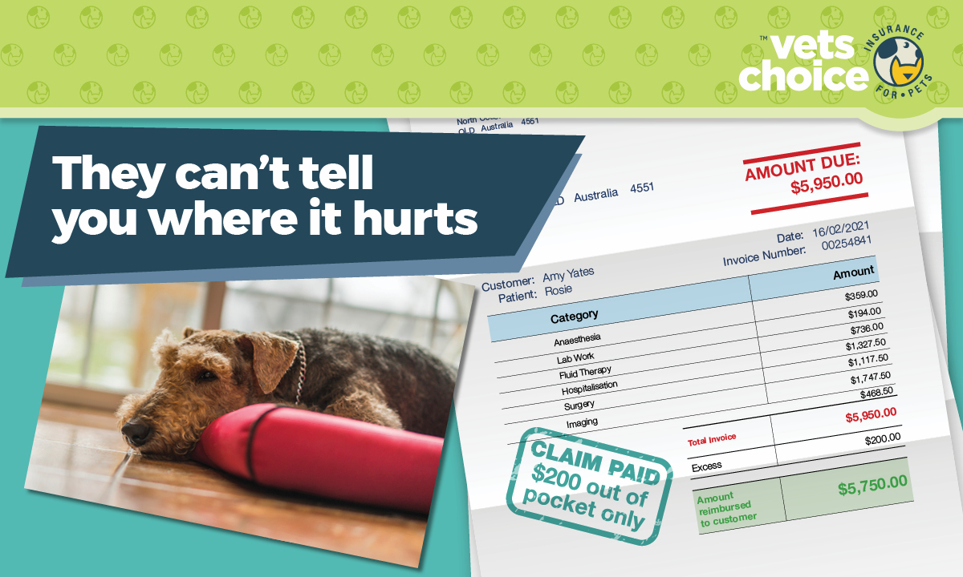EMAIL COPY
Dear (Valued Customer),
We do what we do because - like you, we love animals. Nothing makes us happier than caring for furry family members and friends.
We take the health of your pet seriously, especially when they need urgent care. For many pets, something completely innocent can lead to an emergency.
For Rosie the Airedale Terrier, her emergency started when she swallowed something she shouldn’t have. She ended up needing treatment and emergency surgery that cost $5,950.
Ingesting a foreign object is a common occurrence among pets, as they use their mouth to play and explore the world around them. Not all objects ingested require surgery. However, when emergency treatment is needed, we often use the same machinery, treatment methods and similar medications to look after your pet as a human hospital does.
Unlike human care, there’s no Medicare for pets. Which means often, in emergencies, treatment costs can add up.
Pet insurance is a great way to cover the financial side of pet care, and works in a similar way to private health insurance for people.
Luckily for Rosie, she was insured by Vets Choice insurance for pets, who covered the claim. Rosie’s owners only paid their $200 excess. You can read Rosie’s full story by clicking the button below.
To find out how Vets Choice insurance can help protect your pet, visit vetschoice.net.au or call 1800 999 738.
Kind regards
(Enter your practice name here)

DISCLAIMER
Insurance issued by Guild Insurance Ltd, ABN 55 004 538 863, AFSL 233791 and subject to terms, conditions and exclusions. This information is of a general nature only, please refer to the policy for details. For more information contact Guild Insurance on 1800 999 738.

