Teddy’s story email template

EMAIL IMAGE

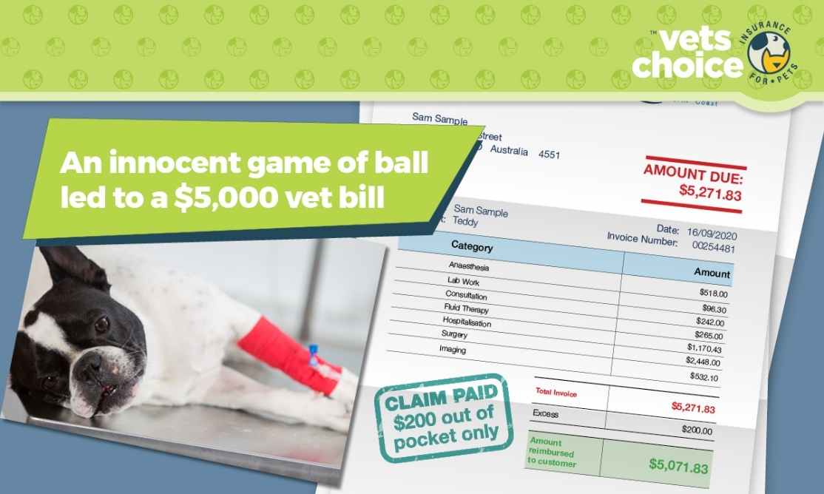

EMAIL COPY
Dear (Valued Customer),
We do what we do because - like you, we love animals. Nothing makes us happier than caring for furry family members and friends.
We know they get up to mischief. They jump, run and act silly because that’s who they are. However, despite the fact that they act invincible, they can injure themselves as easily as we can.
We take the health of your pet seriously, especially when they need urgent care. Just like emergency care for people, we use the same machinery, treatment methods and similar medications to ensure your pet is looked after.
However, unlike human care, there’s no Medicare for pets. Which means often, in emergencies, treatment costs can add up.
Pet insurance is a great way to cover the financial side of pet care, and works in a similar way to private health insurance for people.
You never know how quickly a small incident can become a big shock. Just like the game of ball for Teddy the French Bulldog, that turned into emergency surgery and a $5,000 bill.
Luckily, Vets Choice insurance for pets covered the claim and Teddy’s owners only paid their $200 excess. Everyone involved could focus on getting Teddy back to good health, instead of worrying about the bill.
To find out how Vets Choice insurance can help protect your pet, visit vetschoice.net.au or call 1800 999 738.
Kind regards
(Enter your practice name here)

Disclaimer
Insurance issued by Guild Insurance Ltd, ABN 55 004 538 863, AFSL 233791 and subject to terms, conditions and exclusions. This information is of a general nature only, please refer to the policy disclosure statement (PDS) for more details. For more information contact Guild Insurance on 1800 999 738.

