Teddy’s story social posts

POST 1
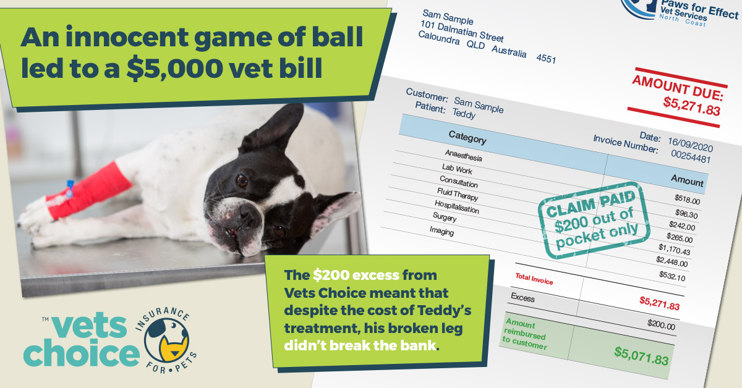

When Teddy started limping after jumping for his ball, his owners acted quickly and took him to the vet. An x-ray and operation later, Teddy’s broken leg was on the mend. But little did his owners know how much it would cost to get the treatment he needed.
That’s when Vets Choice insurance for pets stepped in. Vets Choice paid the claim, leaving Teddy's owners to only pay their $200 excess, instead of a bill over $5,000.
Be like Teddys’ owners and choose sensible, with a Vets Choice insurance for pets policy, visit vetschoice.net.au today.

POST 2

We know pets get up to mischief. They jump, run and act silly because that’s who they are. However, despite the fact they act invincible, they can injure themselves as easily as we can.
That’s why pet insurance is a great way to ensure your pet can get the care they need. You never know when your dog might hurt their leg, just like Teddy the French bulldog did.
Teddy broke his leg playing ball, and needed emergency surgery to fix the fracture, resulting in a bill that was over $5,000. But with Vets Choice insurance for pets, his owners only paid their $200 excess, and Vets Choice handled the rest.
Be like Teddys’ owner and choose sensible, with a Vets Choice insurance for pets policy. To find out how more, visit vetschoice.net.au

